Discipleship Is Not a Curriculum—It Is a Process
How effective is the church today?
will leave the church when they enter college.
will stay in the church as lethargic and apathetic believers.
will stay in the church who have a heart for the Great Commission and a Christian worldview.
God’s Plan and Purpose for Children Today
- (Romans 10:9)
- They are by the Holy Spirit. (Eph. 1:13)
- They receive the .
- They receive from the Holy Spirit. (1 Cor. 13:2)
What Is Our Calling?
- We are called to them. (Matt. 28:19-20)
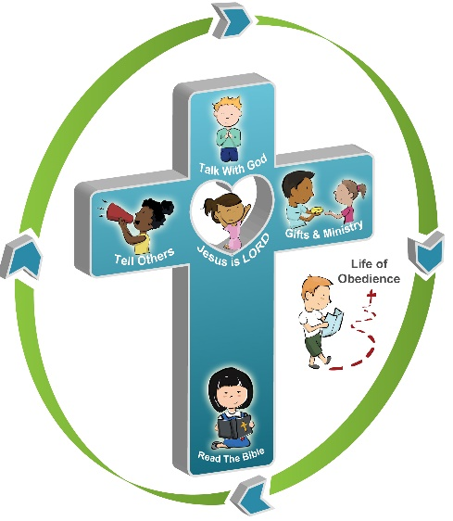
- We are called to them for ministry. (Eph. 4:11-13)
Six Spiritual Disciplines That Bring Transformation
Lordship: _____________________________________________
_____________________________________________________
Bible Study: ___________________________________________
_____________________________________________________
Prayer: _______________________________________________
______________________________________________________
Evangelism: ____________________________________________
_______________________________________________________
Gifts & Ministry: _________________________________________
_______________________________________________________
Life of Obedience: _______________________________________________________________
____________________________________________________________________________________________________________________________________________________________

